Install Nginx and run Nginx on port number 81.
- Sudo apt update
- Sudo apt install nginx -y
- Next, we need to open Nginx's configuration file to change its port from 80 to 81. Run this command to open the file in a text editor
- sudo nano /etc/nginx/sites-available/default
- listen 81 default_server;
- listen [::]:81 default_server;

Deploy your sample index.html
- echo "<h1>Hello from Nginx running on Port 81</h1>" | sudo tee /var/www/html/index.html
- To prove it's working, run this test command to see if Nginx replies
- curl http://localhost:81

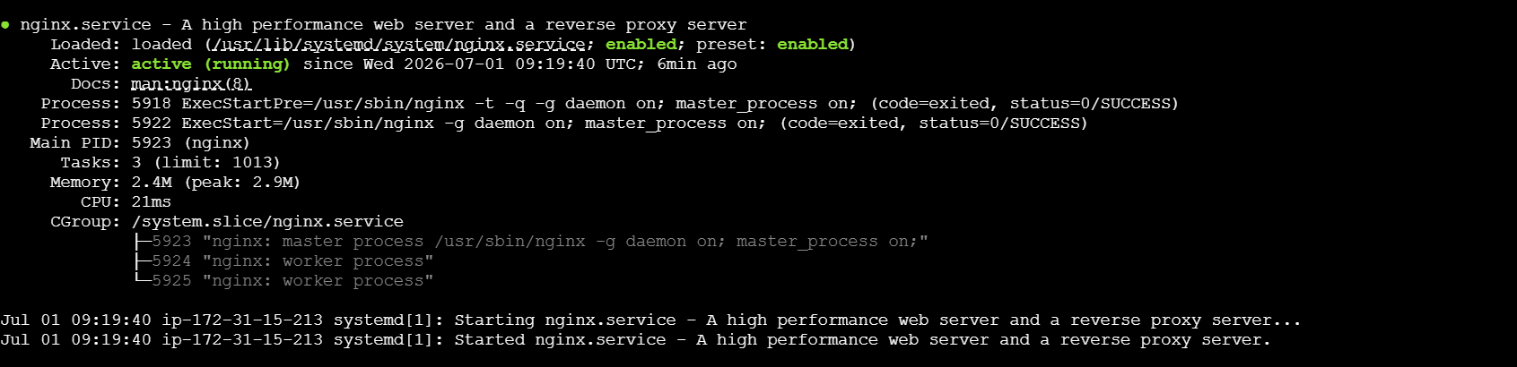

3. Install Apache & Run on Port 82
- First, install the Apache web server software
- sudo apt install apache2 -y
- Now, we need to tell Apache to listen on port 82 instead of 80
- sudo nano /etc/apache2/ports.conf
- Change the line Listen 80 to Listen 82
- Next, we must update the default website configuration file so it knows it lives on port 82
- sudo nano /etc/apache2/sites-available/000-default.conf

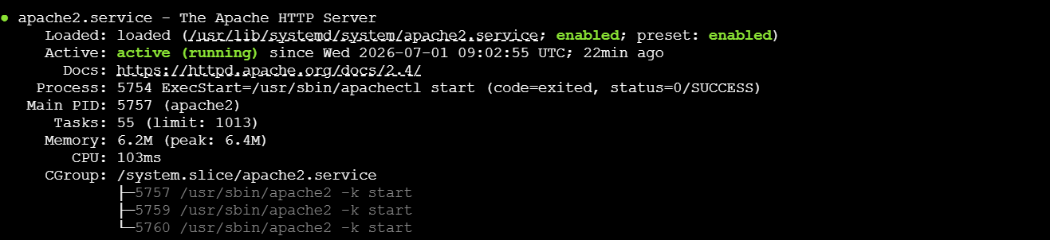

4.Deploy your Apache index.html
- echo "<h1>Hello from Apache running on Port 82</h1>" | sudo tee /var/www/html/index.html
- Now, restart Apache to apply all of your changes
- sudo systemctl restart apache2
- Run this quick command to verify Apache is answering beautifully on its new port
- curl http://localhost:82

5.Install Java & Tomcat
- Tomcat requires Java to run, so let's install that first
- sudo apt install default-jdk -y
- Now, let's download the Tomcat software package directly to your server
- wget https://archive.apache.org/dist/tomcat/tomcat-10/v10.1.34/bin/apache-tomcat-10.1.34.tar.gz
- Create a home folder for Tomcat and unpack the downloaded files into it
- sudo mkdir -p /opt/tomcat
- sudo tar -xzvf apache-tomcat-10.1.34.tar.gz -C /opt/tomcat --strip-components=1
- Now, let's change Tomcat's port from its default 8080 to your required 8082. Open its configuration file:
- sudo nano /opt/tomcat/conf/serv

6. Deploy a Sample Apper.xml
- Tomcat looks inside a folder called webapps to run applications. Let's create a folder called sample inside it and drop an index.html file there
- sudo mkdir -p /opt/tomcat/webapps/sample
- echo "<h1>Hello from Tomcat App running on Port 8082</h1>" | sudo tee /opt/tomcat/webapps/sample/index.html

Step 7: Create the tomcat.service File
- To make sure Tomcat runs automatically in the background as a proper system service, let's create a service file for it:
- sudo nano /etc/systemd/system/tomcat.service
- Copy and paste this entire block of text directly into your editor
- [Unit]
- Description=Apache Tomcat Web Application Container
- After=network.target

- [Service]
- Type=forking
- Environment=JAVA_HOME=/usr/lib/jvm/default-java
- Environment=CATALINA_PID=/opt/tomcat/temp/tomcat.pid
- Environment=CATALINA_HOME=/opt/tomcat
- Environment=CATALINA_BASE=/opt/tomcat
- ExecStart=/opt/tomcat/bin/startup.sh
- ExecStop=/opt/tomcat/bin/shutdown.sh
- User=root

- [Install]
- WantedBy=multi-user.target
- Now tell your server to look at this new service file and start Tomcat up
- sudo systemctl daemon-reload
- sudo systemctl start tomcat
- sudo systemctl enable tomcat
- Run this command to check if your Tomcat application is live
- curl http://localhost:8082/sample/

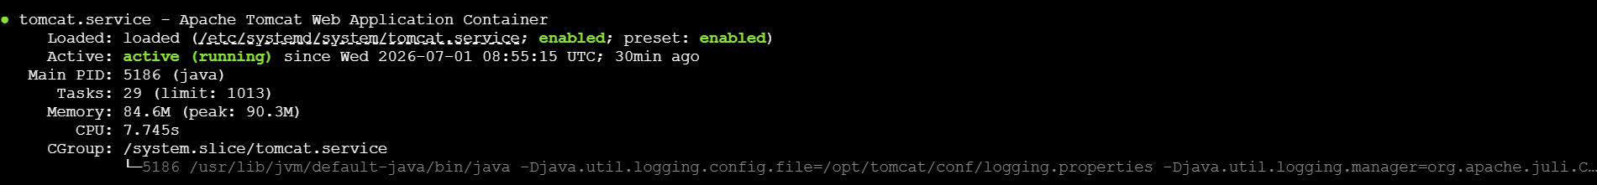

Step 8: Install & Configure HAProxy
- First, install the HAProxy software
- sudo apt install haproxy -y
- Now, let's open the HAProxy configuration file to tell it where your web servers are hiding
- sudo nano /etc/haproxy/haproxy.cfg
- croll all the way down to the very bottom of the file using your arrow keys. Move to a clean new line at the end, then copy and paste this exact block of text
- frontend http_front
- bind *:80
- default_backend web_servers

- backend web_servers
- balance roundrobin
- server nginx_node 127.0.0.1:81 check
- server apache_node 127.0.0.1:82 check
- Now, restart HAProxy so it starts routing traffic
- sudo systemctl restart haproxy
- sudo systemctl enable haproxy
- HAProxy is now running on standard port 80. If you ask it for a web page multiple times, it will alternate back and forth between Nginx and Apache
- curl http://localhost

